Task 3: Dataset Preparation and Preprocessing for Deep Learning
Dataset: CIFAR-10

Objective
Prepare and preprocess the CIFAR-10 image dataset for deep learning by performing exploratory data analysis, data-quality checks, normalization, augmentation, visualization, and train-validation-test splitting.

Tools and Libraries
- Python
- TensorFlow / Keras
- NumPy
- Pandas
- Matplotlib
- Seaborn

Dataset
CIFAR-10 contains 60,000 color images of size 32×32 pixels belonging to 10 classes.

1. Import Libraries
Source Code
import numpy as np
import pandas as pd
import matplotlib.pyplot as plt
import seaborn as sns
import tensorflow as tf
from tensorflow.keras.datasets import cifar10
from tensorflow.keras import layers
print("TensorFlow version:", tf.__version__)
np.random.seed(42)
tf.random.set_seed(42)
Output
TensorFlow version: 2.20.0

2. Load the CIFAR-10 Dataset
Source Code
(x_train_full, y_train_full), (x_test, y_test) = cifar10.load_data()
class_names = [
"airplane", "automobile", "bird", "cat", "deer",
"dog", "frog", "horse", "ship", "truck"
]
print("Original training images:", x_train_full.shape)
print("Original training labels:", y_train_full.shape)
print("Test images:", x_test.shape)
print("Test labels:", y_test.shape)
Output
Original training images: (50000, 32, 32, 3)
Original training labels: (50000, 1)
Test images: (10000, 32, 32, 3)
Test labels: (10000, 1)

3. Dataset Overview
Source Code
print("Total images:", len(x_train_full) + len(x_test))
print("Image shape:", x_train_full.shape[1:])
print("Number of classes:", len(class_names))
print("Data type:", x_train_full.dtype)
print("Minimum pixel value:", x_train_full.min())
print("Maximum pixel value:", x_train_full.max())
Output
Total images: 60000
Image shape: (32, 32, 3)
Number of classes: 10
Data type: uint8
Minimum pixel value: 0
Maximum pixel value: 255

4. Exploratory Data Analysis (EDA)
Source Code — Sample images from each class
plt.figure(figsize=(15, 6))
for class_id in range(10):
index = np.where(y_train_full.flatten() == class_id)[0][0]
plt.subplot(2, 5, class_id + 1)
plt.imshow(x_train_full[index])
plt.title(class_names[class_id])
plt.axis("off")
plt.suptitle("One Sample Image from Each CIFAR-10 Class", fontsize=16)
plt.tight_layout()
plt.show()
Screenshot / Output
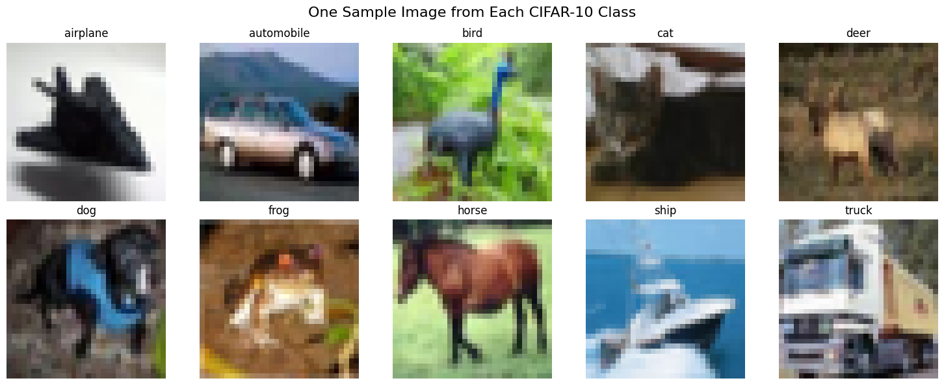
Source Code — Class distribution
class_counts = pd.Series(y_train_full.flatten()).value_counts().sort_index()
distribution_df = pd.DataFrame({"Class": class_names, "Number of Images": class_counts.values})
display(distribution_df)
sns.barplot(data=distribution_df, x="Class", y="Number of Images")
plt.title("CIFAR-10 Training Class Distribution")
plt.show()
Screenshot / Output
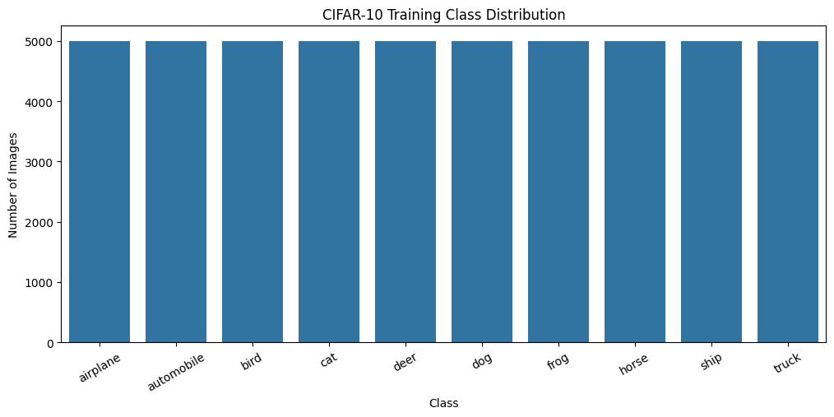
Each of the 10 classes contains exactly 5,000 images in the training set, confirming the dataset is perfectly balanced.
Source Code — Pixel value distribution
sample_pixels = x_train_full[:1000].reshape(-1)
plt.hist(sample_pixels, bins=50)
plt.title("Pixel Value Distribution Before Normalization")
plt.show()
Screenshot / Output
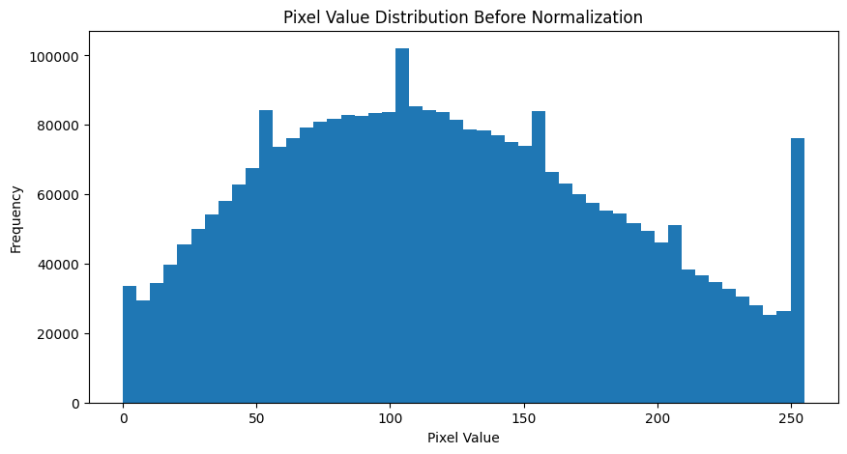

5. Data Quality Checks
The CIFAR-10 arrays were checked for missing values, invalid pixel values, invalid labels, unexpected image dimensions, and duplicate images within a manageable subset.
Source Code
print("Missing values in training images:", np.isnan(x_train_full).sum())
print("Missing values in test images:", np.isnan(x_test).sum())
print("Unique training labels:", np.unique(y_train_full))
print("Training pixel range:", x_train_full.min(), "to", x_train_full.max())
print("Training image shape valid:", x_train_full.shape[1:] == (32, 32, 3))
Output
Missing values in training images: 0
Missing values in test images: 0
Missing values in training labels: 0
Missing values in test labels: 0
Unique training labels: [0 1 2 3 4 5 6 7 8 9]
Unique test labels: [0 1 2 3 4 5 6 7 8 9]
Training pixel range: 0 to 255
Test pixel range: 0 to 255
Training image shape valid: True
Test image shape valid: True
Source Code — Duplicate check
subset = x_train_full[:10000]
flat_subset = subset.reshape(len(subset), -1)
unique_count = np.unique(flat_subset, axis=0).shape[0]
print("Images checked:", len(subset))
print("Unique images:", unique_count)
print("Duplicate images in checked subset:", len(subset) - unique_count)
Output
Images checked: 10000
Unique images: 10000
Duplicate images in checked subset: 0

6. Train-Validation-Test Split
Source Code
validation_size = 5000
x_val = x_train_full[-validation_size:]
y_val = y_train_full[-validation_size:]
x_train = x_train_full[:-validation_size]
y_train = y_train_full[:-validation_size]
print("Training set:", x_train.shape, y_train.shape)
print("Validation set:", x_val.shape, y_val.shape)
print("Test set:", x_test.shape, y_test.shape)
Output
Training set: (45000, 32, 32, 3) (45000, 1)
Validation set: (5000, 32, 32, 3) (5000, 1)
Test set: (10000, 32, 32, 3) (10000, 1)

7. Image Preprocessing — Normalization
Source Code
x_train_norm = x_train.astype("float32") / 255.0
x_val_norm = x_val.astype("float32") / 255.0
x_test_norm = x_test.astype("float32") / 255.0
print("Training pixel range after normalization:", x_train_norm.min(), "to", x_train_norm.max())
print("Data type:", x_train_norm.dtype)
Output
Training pixel range after normalization: 0.0 to 1.0
Data type: float32
Screenshot / Output — Normalized images
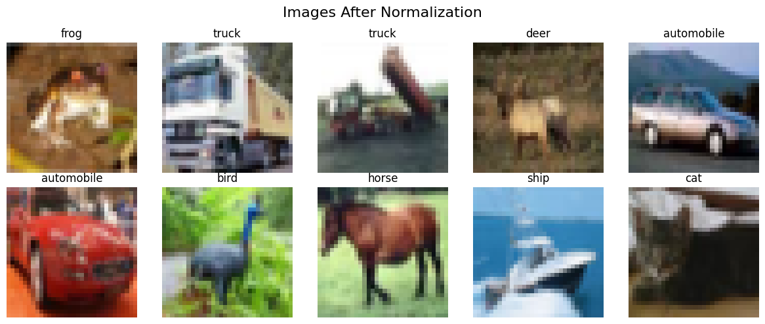

8. Image Augmentation
Augmentation is applied only to training images; validation and test images are kept unaugmented.
Source Code
data_augmentation = tf.keras.Sequential([
layers.RandomFlip("horizontal"),
layers.RandomRotation(0.1),
layers.RandomZoom(0.1),
layers.RandomTranslation(0.1, 0.1)
], name="data_augmentation")
data_augmentation.summary()
Source Code — Visualize augmentations
sample_image = tf.expand_dims(x_train_norm[0], axis=0)
for i in range(10):
augmented_image = data_augmentation(sample_image, training=True)[0]
plt.subplot(2, 5, i + 1)
plt.imshow(tf.clip_by_value(augmented_image, 0, 1))
plt.axis("off")
plt.suptitle(f"Augmented Versions of: {class_names[int(y_train[0])]}")
plt.show()
Screenshot / Output
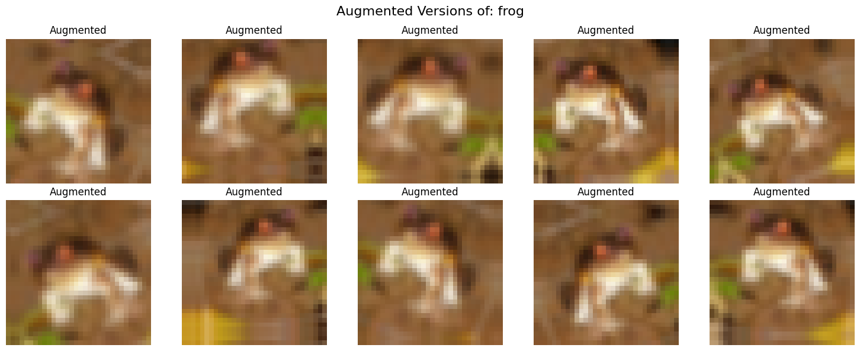

9. Prepare TensorFlow Datasets
Source Code
BATCH_SIZE = 64
AUTOTUNE = tf.data.AUTOTUNE
train_ds = tf.data.Dataset.from_tensor_slices((x_train_norm, y_train))
val_ds = tf.data.Dataset.from_tensor_slices((x_val_norm, y_val))
test_ds = tf.data.Dataset.from_tensor_slices((x_test_norm, y_test))
train_ds = train_ds.shuffle(10000, seed=42).batch(BATCH_SIZE).prefetch(AUTOTUNE)
val_ds = val_ds.batch(BATCH_SIZE).prefetch(AUTOTUNE)
test_ds = test_ds.batch(BATCH_SIZE).prefetch(AUTOTUNE)
print("TensorFlow datasets created successfully.")
Output
TensorFlow datasets created successfully.

10. Verify the Preprocessed Dataset
Source Code
images_batch, labels_batch = next(iter(train_ds))
print("Batch image shape:", images_batch.shape)
print("Batch label shape:", labels_batch.shape)
print("Batch pixel range:", tf.reduce_min(images_batch).numpy(), "to", tf.reduce_max(images_batch).numpy())
print("Batch image dtype:", images_batch.dtype)
Output
Batch image shape: (64, 32, 32, 3)
Batch label shape: (64, 1)
Batch pixel range: 0.0 to 1.0
Batch image dtype: <dtype: 'float32'>
Screenshot / Output — Final preprocessed batch
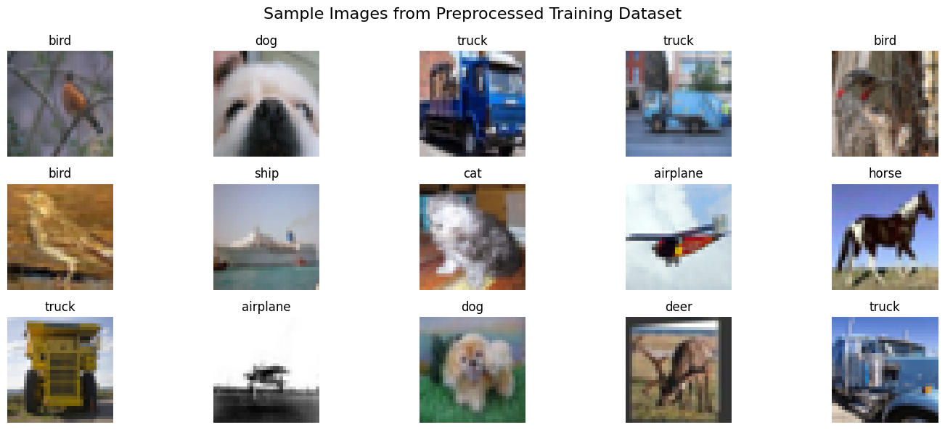

11. Preprocessing Summary
Step | Operation
Dataset loading | CIFAR-10 loaded using Keras
EDA | Image samples, dimensions, class distribution and pixel distribution
Data quality | Missing values, labels, dimensions, pixel ranges and duplicates checked
Train split | 45,000 images
Validation split | 5,000 images
Test split | 10,000 images
Normalization | Pixel values scaled from 0–255 to 0–1
Augmentation | Horizontal flip, rotation, zoom and translation
TensorFlow pipeline | Batching, shuffling and prefetching

Important Preprocessing Decision
Data augmentation is applied only to the training data. Validation and test data are kept unaugmented so that evaluation represents the model's performance on the original data distribution.

12. Observations
1. CIFAR-10 contains RGB images with dimensions 32×32×3 and ten target classes.
2. The dataset is approximately balanced across the ten classes.
3. Pixel values initially range from 0 to 255.
4. No missing values were found in the loaded CIFAR-10 arrays.
5. Labels are valid integer class IDs from 0 to 9.
6. Normalization scales pixel values to the range 0–1, making them more suitable for neural-network training.
7. Image augmentation creates additional variation in training samples and can help reduce overfitting.
8. The final dataset is divided into training, validation and test sets.
9. The resulting TensorFlow datasets are batched and prefetched for efficient deep-learning training.

13. Conclusion
The CIFAR-10 dataset was successfully prepared for deep learning. Exploratory analysis was performed, data quality was checked, images were normalized, training images were augmented, and the dataset was divided into training, validation and test sets. The final tf.data pipelines are ready to be used as input to a CNN or other image-based deep-learning model.

Github Repo:
https://github.com/AdityaBahira/Lnt_Deep_Learning/tree/main/Task%203:%20Dataset%20Preparation%20and%20Preprocessing%20for%20Deep%20Learning

